**F O R T H E**

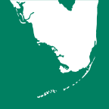

**E S T U D E N T**

U.S. Department of the Interior

**Land and People : Finding a Balance**

Everglades

U.S. Geological Survey

**Finding a Balance** **is an environmental study project that allows you and a group of your classmates to consider real environmental dilemmas concern- ing water use and to provide solutions to these dilemmas. The student packet gives you most of the information you’ll need to answer the Focus Question,**

**information like maps, data, background, a reading about the region, and a description of the “Interested Parties,” or the various interest groups that have a stake in the outcome of the Focus Question. While you are working on this project, each member of your group**

**will take a role, or become one of the**

**interested parties. Your teacher will guide you through a series of discus- sions, activities, calculations, and labs. At the end of this project, your group will be asked to present and justify a solution to the environmental dilemma.**

**Reading**

From *The Everglades: River of Grass* by Marjory Stoneman Douglas (1947).

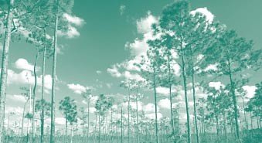“There are no other Everglades in the world. They are, they have always been, one of the unique regions of the earth, remote, never wholly known. Nothing anywhere else is like them: their vast glittering openness, wider than the enormous visible round of the horizon, the racing free saltiness and sweetness of their massive winds, under the dazzling blue heights of space. They are unique also in the simplicity, the diversity, the related harmony of the forms of life they enclose. The miracle of the light pours over the green and brown expanse of saw grass and of water, shining and slow-moving below, the grass and water that is the meaning and central fact of the Everglades of Florida. It is

a river of grass...Where do you begin? Because, when you think of it, history, the recorded time of the earth and of man, is in itself something like a river. To try to present it whole is to find oneself lost in the sense of continuing change. The source can be only the beginning in time and space, and the end is the future and the unknown...

So it is with the Everglades, which have that quality of long existence in

their own nature. They were change- less. They are changed.”

Florida author and conservationist Marjory Stoneman Douglas was born in 1890. Her best-selling book, *The Everglades: River of Grass* was pub- lished in 1947, the same year the 1.4 million acre Everglades National Park, opened. A noted author, editor and environmentalist, she received the Presidential Medal of Freedom in 1993, which she donated to her alum- nus, Wellesley College. At the age of 104, Douglas published a novel, *Freedom River.*

**Focus question**

The year is 2040. The National Weather Service has studied several decades of rainfall rates and the storm patterns over the Atlantic Ocean and has produced an alarming forecast: over the next 5 years, the Everglades- region will experience a 30-percent- decrease in the amount of rainfall it receives. But lack of rainfall is not the only challenge the Everglades faces. During the last century, the Everglades has been profoundly changed by increasing urban and agricultural activ- ity. Humans have drained the wetland and created a complex canal and levee

system, thus causing drastic changes in

**Table 1. Population Growth**

|  |  |  |  |  |  |
| --- | --- | --- | --- | --- | --- |
| the ecosystem: shrinking populations  of wading birds and the collapse of COUNTY | | 1980 | 2010 | NET CHANGE IN NUMBER | NET CHANGE IN PERCENT |
| alligators’ nesting activities. | BROWARD | 1,018,257 | 1,255,488 | +237,231 | +23.3 |
| **How will your group respond to this** | DADE | 1,625,509 | 1,937,094 | +311,585 | +19.2 |
| **serious decrease in rainfall? Create an**  **action plan that will reduce the damage** | PALM BEACH | 576,758 | 863,518 | +286,760 | +49.7 |

**the long period of dry weather will cause to human and ecological interests**.

**The Interested Parties**

Here is an overview of the competing interests that affect the Everglades region. As your group works to answer the Focus Question, each person will take a role as an **environmentalist, farmer, or developer.**

**E N V I R O N M E N T A L I S T S**

Environmentalists want to stop the destruction of the Everglades, an eco- system which is quickly dying. Only one fifth of the water that reached the ecosystem at the turn of the century is getting to the Everglades today. Only 5 percent of the wading birds that used to nest there are still doing so. Agri-

1. **Which county gained the most people between 2000 and 2010? Which county gained the largest percentage of growth during that period?**

**Table 2. Projected Range of Public Supply Water Use Per Day (in millions of gallons)**

|  |  |  |  |
| --- | --- | --- | --- |
| COUNTY | 2020 | 2030 | 2040 |
| BROWARD | 257.4 | 285.4 | 316.2 |
| DADE | 395.8 | 425.5 | 471.4 |
| PALM BEACH | 253.1 | 305.0 | 338.0 |

1. **Which county has the slowest rate of projected use of public water?(To answer this question, subtract the figure for 2020 from the figure for 2040.)**

**Table 3. Total Freshwater Withdrawn Per Day (in millions of gallons)**

COUNTY 1980 1990 2000 2010

|  |  |  |  |  |  |
| --- | --- | --- | --- | --- | --- |
| cultural runoff has severely altered |  | | | | |
| vegetation, replacing saw grass with | BROWARD | 173.13 | 184.35 | 235.58 | 266.53 |
| cattails, which crowd out algae, an | DADE | 287.80 | 276.47 | 440.45 | 490.55 |
| important food source. | PALM BEACH | 414.50 | 504.38 | 752.71 | 996.84 |

**E V E R G L A D E S**

**2**

**A G R I B U S I N E S S**

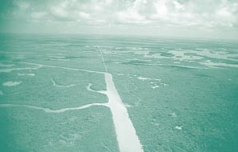South Florida farmers are some of the most productive in the Nation, produc- ing everything from sugarcane, to let- tuce, to tomatoes. To produce these crops, south Florida farmers use a large portion of the region’s water. Irrigation of sugarcane and citrus dominates water use in the six counties that com- prise the Everglades Agricultural Area and the Indian River Citrus Area in Florida. About 1 million acres are irri- gated with more than 2 billion gallons of water per day.

1. **Palm Beach County’s use of freshwater more than doubled between 1980 and 2010. Did Palm Beach County’s population grow at about the same rate?**

Everglades farmers make a lot of money and employ a lot of people. Palm Beach County has the fifth largest farm income in the Nation. Twenty thousand people work in the Everglades Agri- cultural Area on 450,000 acres of land. Farmers plant the rich peat soil that is exposed when surface water is drained. (The Everglades sustains the Nation’s largest sugarcane crop and second largest vegetable crop.) But, exposed to air, this soil decomposes, rapidly dry- ing up and blowing away. Because the soil is exposed to this and, thus, is drier than it would normally be, peat is lost at the rate of between one-quarter and three-fourth inch per year.

In addition to transforming the flow of water, farming introduces runoff that contains phosphorus and nitrogen into the Everglades. This runoff has choked the Everglades’ saw-grass prairies with cattails. In 2004, a sugar cane com- pany, which produces nearly one-third of Florida’s sugar, was required to reduce phosphorus pollution in the water that drains from its lands in the Everglades Agricultural Area. The company also agreed to help build large artificial marshes to filter pollu- tion that flows toward the Everglades National Park.

**U R B A N D E V E L O P E R S**

Developers want the human population to continue to expand in numbers and in the amount of space people take up. The population of Broward county alone has doubled in the last 20 years. (South Florida has one of the fastest growing populations in the U.S.) They also want to offer residents a high standard of living, which in Florida includes high domestic water consump-

**Table 4. Largest Population Growth 1990-2002**

tion. The demand for water drains the aquifers below ground, while more and more pavement inhibits the land’s ability to absorb water.

Developers also build to accommo- date vacationers and retirees. In 2009 alone, 39 million people vacationed in south Florida. Twelve million arrive during the winter, the driest months of the year in south Florida.

**Table 5. Largest Number of New Private Housing Units Authorized by Building Permits 2000-2012**

|  |  |  |  |  |
| --- | --- | --- | --- | --- |
| **COUNTY** | **NUMBER** |  | **COUNTY** | **NUMBER** |
| Los Angeles, CA | 1,576,407 |  | Los Angeles, CA | 53,004 |
| San Diego, CA | 739,209 |  | Clark, NV | 51,996 |
| Maricopa, AZ | 700,392 |  | Maricopa, AZ | 48,210 |
| San Bernardino, CA | 639,327 |  | Harris, TX | 35,356 |
| Riverside, CA | 625,236 |  | Riverside, CA | 32,865 |
| Harris, TX | 562,208 |  | King, WA | 32,437 |
| Orange, CA | 551,868 |  | San Diego, CA | 29,694 |
| Clark, NV | 382,546 |  | San Bernardino, CA | 27,310 |
| Dade, FL | 382,463 |  | Dade, FL | 26,692 |
| Tarrant, TX | 359,239 |  | Broward, FL | 26,011 |
| Dallas, TX | 356,976 |  | Dallas, TX | 25,851 |
| Palm Beach, FL | 323,897 |  | Palm Beach, FL | 25,665 |
| Sacramento, CA | 309,856 |  | Orange, FL | 25,521 |
| King, WA | 287,639 |  | Orange, CA | 24,359 |
| Broward, FL | 283,017 |  | Cook, IL | 23,540 |
| Fairfax, VA | 261,266 |  | Sacramento, CA | 21,003 |
| Bexar, TX | 244,125 |  | Franklin, OH | 19,486 |
| Orange, FL | 243,714 |  | Oakland, MI | 16,352 |
| Santa Clara, CA | 233,456 |  | Mecklenburg, NC | 15,488 |
| Gwinnett, GA | 224,947 |  | Duval, FL | 15,194 |
| Hillsborough, FL | 211,613 |  | Pierce, WA | 15,126 |
| Alameda, CA | 202,193 |  | Tarrant, TX | 14,993 |
| Montgomery, MD | 201,969 |  | Fresno, CA | 14,711 |
| Travis, TX | 193,586 |  | Hillsborough, FL | 14,682 |
| Fresno, CA | 190,992 |  | Wake, NC | 14,533 |
| United States | 28,535,337 |  | United States | 3,154,493 |

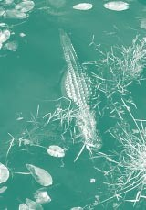**4. How many Florida counties are among the 25 fastest-growing counties in the U.S.? Which of these Florida counties are in the Everglades?**

**S T U D E N T P A C K E T 3**

**5. Dade, Broward, and Palm Beach Counties are permitting many new homes to be built in the Everglades region. What conclusion about people’s impact on the environment can you draw from this fact?**

**4**

**The Everglades – What You Need To Know**

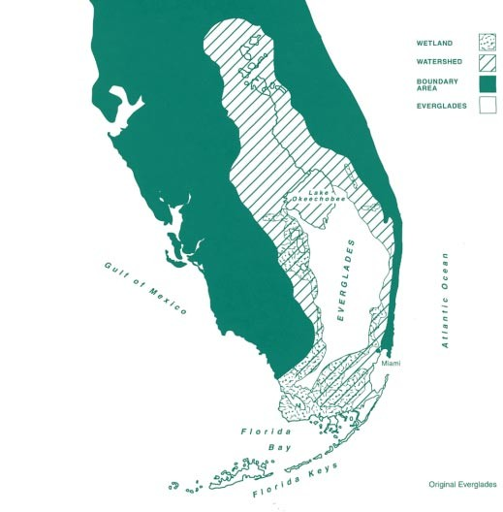

**E V E R G L A D E S**

To understand what the Everglades is today, you need to know what it once was. The pristine Everglades was a wet- land that spanned the state of Florida south of Lake Okeechobee, about 2.9 million acres of mostly peatland covered by tall saw-grass growing in shallow water. When the lake was full, water overflowed into the northern Everglades and moved slowly to the south in a

50-mile-wide sheet, a foot deep. In the 1880’s people began to drain the Kissimmee River-Lake Okeechobee- Everglades watershed. Drainage exposed the organic muck soil, which produced extraordinary crop yields.

The last 100 years have seen tremen- dous change in the Everglades. Water is controlled by a complex management system that includes canals, levees, and pumps. The region is divided into the Everglades Agricultural Area (the world’s

largest zoned farming area), three Water Conservation Areas, and Ever- glades National Park. The Everglades has been called “…the biggest artificial plumbing system in the world.”

Today more than 50 percent of the historic Everglades has been eliminat- ed. Widespread population growth and land-use modification in Florida affect the quantity and quality of drinking water, alter natural wetlands, and increase human exposure to hydrologic

**S T U D E N T P A C K E T 5**

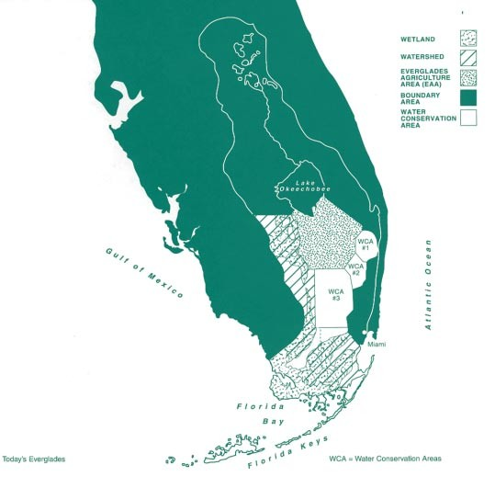

hazards, such as floods. More than 1,400 miles of drainage canals and levees have altered the Everglades wetlands in Florida for flood control. These agricultural, industrial, and urban areas affect water quality in southern Florida. Farming involves the use of numerous chemicals, including fertiliz- ers, insecticides, herbicides, and fungi- cides, that leak into the ground water or nearby surface waters. Stormwater runoff from urban areas commonly

transports heavy metals and nutrients into canals and the Biscayne aquifer.

**Restoring the Everglades — Add Water and Mix?**

The south Florida ecosystem is one of the most threatened ecosystems in the Nation. The greatest impacts on the ecosystems may have resulted from the construction of a complex canal and levee system to control flooding and supply freshwater. This system has

drained over half of the Everglades and altered the flow of freshwater into Florida Bay. Without enough standing water, the ecosystem supports half as much aquatic life, thus the Everglades

can no longer feed the storks, alligators, and other animals that once flourished. Many people believe the lack of water and the change in how and when it flows are the causes for a declining pop- ulation of wading birds and a collapse of nesting activities, and major changes

in plant communities as “weedy” species, such as cattails, invade the wetlands.

Restoring the Everglades begins with returning its water. Plans are being developed to reestablish the natural hydrology of the south Florida ecosys- tem so that water patterns in parts of the historic Everglades more closely resemble those that existed about 150 years ago, before significant human intervention.

A second major restoration effort involves removing nutrients from agri- cultural waste water. In 2004, the State legislature mandated a project that would construct artificial marshes

around the agricultural area to filter phosphorus from the water. The third restoration effort is removal of non- native plants that crowd out indigenous species and reduce wildlife habitat.

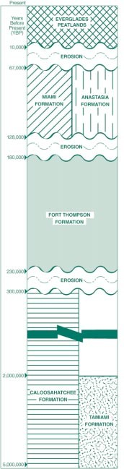

.

**Geologic Background — Flat and Wet**

For most of its geologic history, Florida was under water. The shells of millions of sea animal form the layers of limestone that blanket the State. The peninsula rose above sea level about 20 million years ago. Even then, the southern portion remained largely sub- merged, until the buildup of coral and

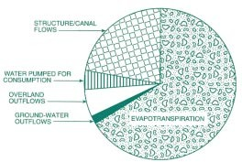

How water is drawn from the Everglades water budget

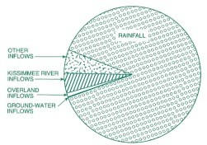

**E V E R G L A D E S**

**6**

How water flows into the Everglades water budget

Geologic Chronology of the Everglades Bedrock Basin

**S T U D E N T P A C K E T 7**

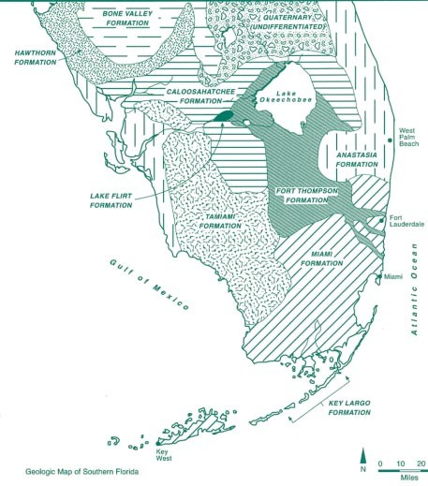

sand around its rim blocked out the sea, leaving dense marine vegetation to decay and form the peaty soil of the present-day Everglades.

Dependent on rain for freshwater, the subtropical stretch of the peninsula receives 40 to 65 inches a year. But this flat, porous limestone land has little surface storage capacity, and after

evaporation, transpiration, and runoff, only a fifth of the rainwater remains to recharge underlying aquifers and shallow lakes.

**Climate — What Does It Mean to be Subtropical?**

South Florida’s climate is rainy, hot and humid. The average annual

temperature is about 75 degrees Fahrenheit. Freezing temperatures are rare. Annual rainfall averages about 53 inches — more than half of which occurs from June through September.

**Glossary**

Use these definitions of important terms as you answer the Everglades Focus Questions.

**AQUIFER-** A geologic formation that con- tains sufficient saturated permeable material to yield economically signifi- cant quantities of water to wells and springs.

**ECOSYSTEM-** The interacting system that encompasses a living community and its non-living physical environment.

**EVAPOTRANSPIRATION-** The conversion of water from a liquid to a vapor including the evaporation of water vapor from plants.

**HYDROLOGIC CYCLE-** The water cycle, which includes evaporation, precipita- tion, and flow of water to the seas. The hydrologic cycle supplies terrestrial organisms with a continual supply of freshwater.

**LEVEE-** A natural or artificial bank that constrains the flow of water to a channel.

**PEAT-** A spongy organic substance made of decayed plant fibers.

**WATER BUDGET-** The freshwater available for plant, animal, and human use

plus the water necessary to maintain streamflow.

**WATERSHED-** All of the land that drains into a particular body of water.

**WETLAND-** Land that is transitional between aquatic and terrestrial ecosystems and is covered with water for at least part of the year

**8**

**E V E R G L A D E S**

**6. These tables allow you to compare crops by the amount of water used to raise them. For example, which crop requires more irrigation — miscellaneous vegetables or sweet corn?**

**7. Which crops require a lot of water? Which ones need very little?**

**8. Which crops did farmers plant more of in 1990 than in 1985? Are these crops ones that use a lot of water?**

**Table 6. Irrigation Acreage and Water Use by Crop Type in Florida**

|  |  |  |  |  |
| --- | --- | --- | --- | --- |
| **BROWARD COUNTY** |  | **1995** |  | **2000** |
| **CROP TYPE** | ACRES FARMED AND IRRIGATED | WATER USE FOR IRRIGATION PER DAY (IN MILLIONS OF GALLONS) | ACRES FARMED AND IRRIGATED | WATER USE FOR IRRIGATION PER DAY (IN MILLIONS OF GALLONS) |
| **TURF GRASS (GOLF COURSES AND OTHER USES)**  **SWEET CORN** | 10,000  6,100 | 16.82  5.57 | 18,000  3,072 | 26.80  3.45 |

**Table 7. Irrigation Acreage and Water Use by Crop Type in Florida**

|  |  |  |  |  |
| --- | --- | --- | --- | --- |
| **PALM BEACH COUNTY** |  | **1995** | **2000** | |
| **CROP TYPE** | ACRES FARMED AND IRRIGATED | WATER USE FOR IRRIGATION PER DAY (IN MILLIONS OF GALLONS) | ACRES FARMED AND IRRIGATED | WATER USE FOR IRRIGATION PER DAY (IN MILLIONS OF GALLONS) |
| **SWEET CORN** | 29,500 | 32.04 | 28,475 | 31.04 |
| **MISCELLANEOUS VEGETABLES** | 30,100 | 11.17 | 44,300 | 48.28 |
| **SUGAR CANE** | 320,000 | 381.97 | 323,433 | 505.33 |
| **TURF GRASS (GOLF COURSES** | 15,000 | 31.36 | 30,000 | 59.80 |
| **AND OTHER USES)** |  |  |  |  |

**Table 8. Irrigation Acreage and Water Use by Crop Type in Florida**

|  |  |  |  |  |
| --- | --- | --- | --- | --- |
| **DADE COUNTY** |  | **1995** | **2000** | |
| **CROP TYPE** | ACRES FARMED AND IRRIGATED | WATER USE FOR IRRIGATION PER DAY (IN MILLIONS OF GALLONS) | ACRES FARMED AND IRRIGATED | WATER USE FOR IRRIGATION PER DAY (IN MILLIONS OF GALLONS) |
| **MISCELLANEOUS FRUIT** | 21,300 | 49.23 | 14,530 | 22.95 |
| **MISCELLANEOUS VEGETABLES** | 33,630 | 3.90 | 28,815 | 33.64 |
| **TURF GRASS (GOLF COURSES** | 7,750 | 18.00 | 47,000 | 17.39 |
| **AND OTHER USES)** |  |  |  |  |